**REQUIREMENTS DOCUMENT**

Project: Design an Autonomous Robot

Task: To design an autonomous robot that is capable of navigating to a predetermined position while avoiding obstacles and firing objects at two targets. This is to be done in the shortest time possible.

Document Version Number: 1.0

Date: Feb 23rd 2015

Author: Gwyneth Pang and Eric Vuong

Contents

Capabilities 3

Purpose 3

Scope*(Subject to change) 3

Questions: 3

Play Area Specifications: 4

Constraints 5

User Functions 5

Operating Environment 6

Composition of surface 6

Ambient Lighting 6

Performance 6

Compatibility 6

Compatibility re-use 6

Compatibility with Third Party Products 6

Glossary of Terms 6

# Capabilities

## Purpose

The purpose is to create an autonomous robot, mechanical and software aspects with the available resources, notably the three NXT kits and the Java programming language. This robot must localize its position, travel to the shooting area of the 12’ x 12’ field, shoot one or two ping-pong balls into the two target areas that are outside of the field, and return to its starting position in the shortest amount of time. Furthermore, the 12’ x 12’ field will contain obstacles, except for the specified zones without obstacles, red zones on the project description map.

## Scope*(Subject to change)

### Questions:

**Should the robot use more than one NXT brick?**   
To start, one brick should be used to keep things simple.

**Before starting the software design, should the hardware be completed?**It is important to complete the hardware design first as a slight modification in the hardware can affect the robot’s weight. As a result, the robot’s odometer may fail.

**Should the robot go past all objects in the middle or sneak into the “safe” zone?**Answer to be determined. More knowledge on the progress of the software and hardware is required.

**What is the time limit for each phase of the competition?**Answer to be determined. Should be asked during the first meeting.

## Play Area Specifications:

The area is a 12 x 12 enclosure containing several obstacles. The each tile’s dimension is 30.48 cm x 30.48 cm. Thus, the robot must travel at least approximately 4 meters to reach its destination. The odometry design must then be precise enough for distances over 4 meters. The tiles in red as indicated in area 6 and 8 are guaranteed to be free of obstacles. For the rest of the area, there will be obstacles placed randomly. To fire the ping-pong balls, the robot must be on the green tiles on area 9.T1 and T2 are the target location where the robot will have to fire its ping-pong balls to (no more than 3 ping-pong balls may be fired at any one target). Once the robot is done firing, the robot must navigate back to the initial position (0,0) as indicated in **Figure 1**. and face North.

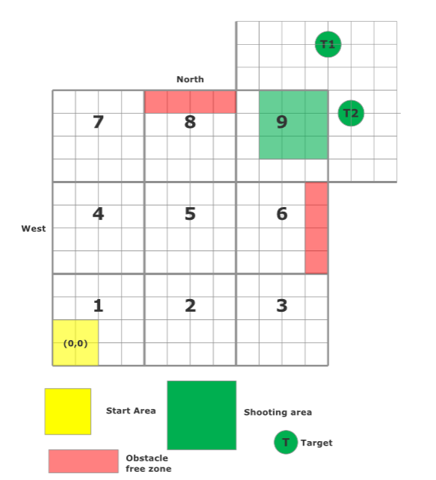

**Figure 1.**  A representation of the area.

# Constraints

The constraints on the design mainly include the three NXT kits and the available resources. The three NXT kits will limit the size of the chassis, which will limit the amount of available space to put the sensors and the launching system. Furthermore, the chassis must withstand the weight of the NXT consoles, the sensors, and the forces of the launching system. Also, the motor of the wheels cannot run for extended periods of time, due to the design of the motors themselves, which limits the run time of the robot. The sensors also have their own limitations. For example, the light sensor’s values will change depending on the brightness of the current location, so if the robot is moved, the light sensor will need to be calibrated again. The ultrasonic sensor will also read more noise in noisy areas, so the ultrasonic sensor will need to be calibrated for the day of the competition. Finally, the limitation of the resources will cause a time restriction for each task in order to not overload the resources.

# User Functions

During the competition, the robot must be autonomous. In other words, there can be no interaction with the robot during the operation. Before the operation, the robot will be placed at an arbitrary position pointing in a random direction within the yellow zone of area 1. The ping-pong balls can be loaded to the robot manually prior to the operation. However, during the operation, the robot must be autonomous enough to fire the balls.

# Operating Environment

## Composition of surface

The robot will be operated on wooden tiles with gridlines of color black. The color difference of the wooden tiles and the grid lines should be different enough for the light sensor to differentiate between the two under normal lighting conditions. Also, the robot’s light sensor will use floodlight to obtain more constant results and any presence of shadows shouldn’t affect the data collection (Further tests will be conducted on the accuracy and consistency of the light sensor).

## Ambient Lighting

The ambient lighting will be mainly composed of normal light bulb light (incandescent light bulbs) directly above the play area. This shouldn’t affect the robot’s lightsensor reading as floodlight will be turned on for more precise data collection.

# Performance

Refer to “Play Area Specifications” under “Scope” in tables of content for more information about the performance requirements.

# Compatibility

## Compatibility re-use

## In the design of the robot, the software from labs 1 through 5 will be reused, but re-calibrated for the new design. The navigation lab’s code will be re-used, in order to fulfil the traveling part of the task. Then, the localization lab will be re-used for the localization part of the task. The wall follower and the odometry from the first and the second labs were already implemented in the navigation lab. Lastly, the ballistics lab will cover the ballistics part of the task. Thus, the only software that needs to be developed is the implementation of the labs in order to make the robot function.

## Compatibility with Third Party Products

No particular third party software or hardware is asked in particular by the client as of February 23rd.

# Glossary of Terms

N/A